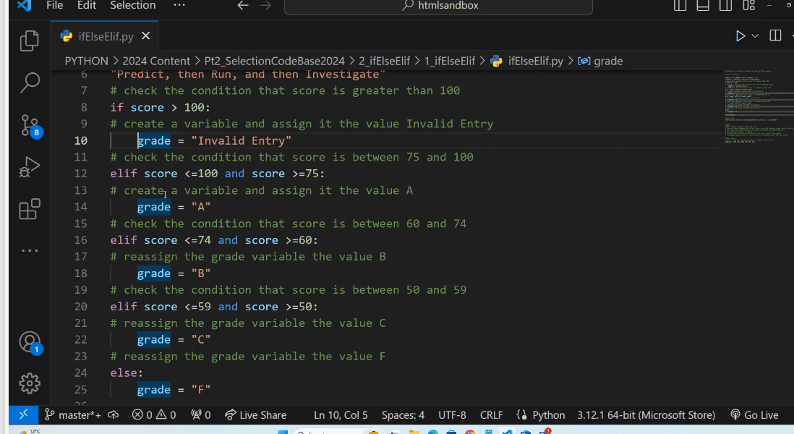

Visual Code extension is called **FLASK** to tie back-end to front-end for full stack development.